
Predict Solar Output Using Time-Series and Machine-Learning Techniques

A CAPSTONE PROJECT REPORT

A Capstone Project Report submitted in partial fulfilment of the requirements for the Course of

ITA0402 STATISTICS WITH R PROGRAMMING

to the award of the degree of

BACHELOR OF ENGINEERING / BACHELOR OF TECHNOLOGY
IN
Artificial Intelligence & Machine Learning

Submitted by
M Harinath (192425020)
S Yuva Guru Mani Varma (192425005)
Karthik V (192425071)
Adhavan M G (192421422)

Under the Supervision of

Dr Jaithunbi A K

SIMATS ENGINEERING
Saveetha Institute of Medical and Technical Sciences
Chennai-602105

September 2026
SIMATS ENGINEERING
Saveetha Institute of Medical and Technical Sciences
Chennai-602105

BONAFIDE CERTIFICATE

This is to certify that the Capstone Project entitled “Predict Solar Output Using Time-Series and Machine-Learning Techniques” has been carried out by S Yuva Guru Mani Varma (192425005) Karthik V (192425071) Harinath M (192425002) and Adhavan M G (192421422) under the supervision of Dr Jaithunbi A K and is submitted in partial fulfilment of the requirements for the current semester of the B.Tech AI & ML program at Saveetha Institute of Medical and Technical Sciences, Chennai.

COURSE COORDINATOR COURSE FACULTY
Dr.Vignesh Janarthanan Dr.A.K.Jaithunbi
PROFESSOR PROFESSOR
Nano Computing Intelligence System
SIMATS Engineering, SIMATS Engineering,
SIMATS, Chennai – 602105. SIMATS, Chennai – 602105.

SIMATS ENGINEERING
Saveetha Institute of Medical and Technical Sciences
Chennai-602105

DECLARATION

I am S. Yuva Guru Mani Varma(192425005) of the AI&ML , SIMATS Engineering, Saveetha Institute of Medical and Technical Sciences, Chennai, hereby declare that the Capstone Project Work entitled “Predict Solar Output Using Time-Series and Machine-Learning Techniques” is the result of our own Bonafide efforts. To the best of our knowledge, the work presented herein is original, accurate, and has been carried out in accordance with the principles of engineering ethics and academic integrity. All sources, references, data, and other materials used in the project have been appropriately acknowledged. We further declare that the data, results, analysis, and findings presented in this report have not been fabricated, falsified, or manipulated. Any external tools, software, datasets, computational resources, or AI-assisted tools used during the project have been appropriately disclosed. We confirm that all applicable ethical, academic, institutional, and professional requirements have been duly followed throughout the planning, execution, analysis, and documentation of the project.

Place: SIMATS, Chennai
Date:

S . Yuva Guru Mani Varma(192425005
Signature of the Students with Names

Individual Contribution Statement

Student Name / Register No. | Specific Responsibilities | Design & Development Contribution | Testing & Analysis Contribution | Report Contribution | Approx. Contribution (%)
M Harinath  (192425020) | Data collection and preprocessing | Developed the R-based data import, cleaning and preprocessing workflow | Verified missing values, duplicate records and data consistency | Contributed to Introduction and Data Collection & Preprocessing sections | [25%]
Karthik V (192425071) | Exploratory Data Analysis | Developed R-based statistical analysis and exploratory visualizations | Analysed solar output trends, distributions and relationships | Contributed to Literature Review and EDA sections | [25%]
S Yuva Guru Mani Varma (192425005) | Forecasting Model Development | Developed and trained time-series and machine-learning forecasting models using R | Compared model performance and tuning results | Contributed to Engineering Design and Forecasting Model sections | [25%]
Adhavan M G (192421422) | Prediction, Evaluation and Visualization | Developed prediction, evaluation and result-visualization workflow in R | Calculated performance metrics and analysed actual vs predicted values | Contributed to Results, Conclusion and Future Work sections | [25%]
Total |  |  |  |  | 100%

ABSTRACT

The intermittent nature of solar photovoltaic (PV) generation presents a significant engineering challenge because actual power output can change considerably with variations in irradiance, weather conditions, and time-dependent generation patterns. A forecasting model is useful only when its predictions are sufficiently accurate and its performance can be clearly interpreted. Therefore, systematic prediction, quantitative evaluation, and visualization are essential for determining the reliability of solar-output forecasting models and supporting their practical application in energy-management systems.
This module focuses on generating solar-output predictions using the forecasting models developed in the previous module and evaluating their performance against actual generation data. The proposed methodology involves loading the trained models, processing unseen test observations, generating predicted solar-output values, and comparing the predictions with corresponding actual measurements. Multiple performance metrics, including Mean Absolute Error (MAE), Root Mean Square Error (RMSE), Mean Absolute Percentage Error (MAPE), and coefficient of determination (R²), are calculated to provide a comprehensive assessment of prediction accuracy. In addition, graphical visualization techniques such as actual-versus-predicted plots, prediction-error graphs, residual analysis, daily generation curves, and model-comparison charts are employed to identify forecasting trends and errors.
The evaluation results demonstrate that the developed forecasting models can reproduce the major temporal patterns of solar generation, including increasing output during daylight hours, peak generation periods, and decreasing output toward sunset. The comparison of evaluation metrics provides a clear basis for identifying the most suitable forecasting model, while error visualization reveals periods where prediction accuracy decreases, particularly during rapid changes in solar generation. The combined numerical and graphical analysis improves the interpretability of the forecasting results.
The module concludes that model evaluation should not depend on a single accuracy metric. Combining statistical measures with visual analysis provides a more reliable understanding of forecasting performance. The final prediction and visualization framework demonstrates the practical potential of machine-learning-based solar forecasting for renewable-energy planning, monitoring, and efficient energy management.
Keywords: Solar Prediction, Model Evaluation, Machine Learning, Forecast Accuracy, Data Visualization, Photovoltaic Energy

TABLE OF CONTENTS

Sl.  No | Title | Page  No
i | CERTIFICATE FROM THE SUPERVISOR | ii
ii | DECLARATION BY THE CANDIDATE | iii
Iii | INDIVIDUAL CONTRIBUTION STATEMENT | iv
iv | ABSTRACT | v
v | LIST OF FIGURES | vi
vi | LIST OF TABLES | vii
vii | LIST OF ABBREVIATIONS | viii
1 | CHAPTER 1: Introduction
2 | CHAPTER 2: Literature Review
3 | CHAPTER 3: Engineering Design & Trade-offs, Sustainability,  Ethics, Safety, Risk & Security
4 | CHAPTER 4: Implementation, Testing & Results, Project  Management
5 | CHAPTER 5: Conclusion & Reflection
 | References
 | Appendices

LIST OF FIGURES
Figure No. | Figure Name | Page No.
1 | Map Monitoring | 30
2 | Dataset Uploading | 31
3 | Model Training | 31
4 | Forecast & Predictions | 32
5 | HTML CODE | 48
6 | Implementation Code | 49

LIST OF TABLES
Table No. | Table Name | Page No.
1 | Comparative Analysis | 16
2 | Requirements | 19
3 | Functional & Non-Functional Requirements | 19
4 | Constraints & Applicable Standards | 20
5 | Design Specifications | 21

CHAPTER 1
INTRODUCTION AND ENGINEERING PROBLEM
1.1 Background
The increasing adoption of solar photovoltaic (PV) systems has created a need for accurate estimation of future solar power generation. Unlike conventional power-generation sources, solar energy depends strongly on environmental and temporal conditions. Solar irradiance, temperature, cloud cover, humidity, time of day, season, and historical generation patterns can cause significant variations in PV output. These variations make it difficult to determine the amount of solar energy that will be available at a future time.
From an engineering perspective, solar-output forecasting is an important component of renewable-energy management. Accurate forecasting can assist grid operators, solar-plant operators, energy-storage systems, and consumers in planning electricity generation and consumption. Time-series and machine-learning techniques provide effective approaches for identifying patterns within historical solar-generation data and using these patterns to estimate future output.
In this project, the forecasting-model development stage focuses on transforming historical solar data into suitable model inputs and developing computational models capable of learning the relationship between time-dependent and environmental variables and solar power output. The developed models form the computational foundation for the subsequent prediction and evaluation stage.

1.2 Need for the Project

1.2.1 Why the Problem Needs to Be Addressed

Solar generation is intermittent and cannot be assumed to remain constant. Sudden changes in weather conditions can produce considerable variations in power output. Without reliable forecasts, energy-management systems may face difficulties in scheduling generation, managing storage, and maintaining an appropriate balance between electricity supply and demand.

Forecasting future solar output allows energy systems to prepare for expected variations rather than responding only after changes occur.

1.2.2 Who Is Affected by the Problem

The problem affects several stakeholders, including:

Solar power-plant operators.

Electrical-grid operators.

Renewable-energy management systems.

Battery and energy-storage operators.

Industrial and commercial electricity consumers.

Researchers and engineers working on smart-grid applications.

1.2.3 Existing Limitations

Conventional forecasting approaches may have limitations when solar generation is affected by multiple nonlinear and rapidly changing factors. Simple statistical models may not adequately capture complex relationships between weather variables and solar output.

Machine-learning models can address some of these limitations by learning patterns directly from historical observations. However, they introduce additional challenges such as feature selection, parameter tuning, computational requirements, overfitting, and the need for high-quality training data.

1.2.4 Engineering Significance

Developing an effective forecasting model can improve renewable-energy planning and provide useful information for grid integration and energy-storage management. From an engineering perspective, the problem requires balancing prediction accuracy, computational complexity, training time, data requirements, and model interpretability.

1.3 Problem Statement

Solar photovoltaic power generation varies continuously due to the interaction of temporal patterns and environmental conditions such as irradiance, temperature, humidity, and weather variations. This creates a technically complex forecasting problem in which the prediction model must learn nonlinear relationships and temporal dependencies from historical data.

The engineering problem is therefore to design and develop a forecasting framework that can process historical solar-generation data, extract meaningful temporal and environmental features, and develop suitable time-series and machine-learning models for predicting future solar output while maintaining acceptable prediction accuracy, computational complexity, and generalization performance under realistic data constraints.

1.4 Project Aim
The aim of this project module is to design and develop suitable time-series and machine-learning forecasting models for predicting solar power output from historical solar-generation and related environmental data.
1.5 Project Objectives
The objectives of Module 3 are:
- To design a structured forecasting framework for solar-output prediction.
- To develop a data-preprocessing pipeline for cleaning and preparing historical solar-generation data.
- To model temporal and environmental relationships using appropriate time-series and machine-learning techniques.
- To implement forecasting algorithms using a suitable programming environment and machine-learning libraries.
- To test the developed models using separate training and testing datasets.
- To evaluate the developed forecasting models using appropriate prediction-performance metrics.
- To identify the model configuration that provides a suitable balance between prediction accuracy and computational complexity.

1.6 Scope

Included

The project includes:

Historical solar-power-generation data analysis.

Data cleaning and preprocessing.

Handling missing and abnormal observations.

Temporal feature extraction.

Feature engineering.

Training and testing dataset preparation.

Development of time-series forecasting models.

Development of machine-learning models.

Model training and parameter selection.

Initial model performance evaluation.

Excluded

The project does not primarily include:

Physical installation of solar panels.

Design of photovoltaic hardware.

Construction of a solar power plant.

Direct control of electrical-grid equipment.

Detailed economic feasibility analysis.

Long-term national-level energy-demand forecasting.

Assumptions

The project assumes that:

Historical data is sufficiently representative of future operating conditions.

Sensor measurements are reasonably accurate.

Required input variables are available for model development.

Data timestamps are correctly recorded.

Training and testing data represent the same general operating environment.

Boundary Conditions

The forecasting model operates within the range of conditions represented in the available dataset. Extremely unusual weather conditions, sensor failures, and conditions outside the training-data distribution may reduce prediction reliability.

1.7 Expected Engineering Outcome
The expected outcome of Module 3 is a software-based solar-output forecasting framework containing:
- A processed solar-generation dataset.
- A feature-engineering pipeline.
- Implemented time-series forecasting models.
- Implemented machine-learning models.
- Trained forecasting models.
- A structured training and testing procedure.
- Model-performance results.
- A selected forecasting approach for the next project stage.
The primary engineering deliverable is therefore a functional forecasting algorithm/model capable of receiving historical and relevant input data and producing estimated solar-power output for future time periods.

CHAPTER 2
LITERATURE REVIEW AND EXISTING SOLUTIONS

2.1 Review Method

The literature review for this module was conducted by examining research and technical studies related to solar-power forecasting, time-series analysis, machine learning, photovoltaic power prediction, feature engineering, and forecasting-model development. Relevant research papers were identified using academic literature databases and technical publications.

The review focused on studies that investigated historical solar-generation data, environmental parameters, statistical forecasting methods, machine-learning algorithms, and deep-learning models. Particular attention was given to the methodology used for data preprocessing, feature selection, temporal modelling, model training, and validation.

Existing forecasting technologies were also considered to understand the practical requirements of solar prediction systems. The reviewed approaches were compared based on prediction capability, data requirements, computational complexity, scalability, and suitability for short-term solar-output forecasting.

2.2 Review of Existing Work

2.2.1 Statistical Time-Series Methods

Traditional solar forecasting methods commonly use time-series models that analyze historical power-generation patterns. Methods such as Autoregressive (AR), Moving Average (MA), Autoregressive Integrated Moving Average (ARIMA), and Seasonal ARIMA (SARIMA) can model temporal dependencies.

These methods are relatively easy to implement and provide interpretable results. However, solar generation is strongly influenced by external environmental variables. Consequently, purely historical approaches may not adequately capture nonlinear changes caused by weather conditions.

2.2.2 Linear Regression

Linear regression is frequently used as a baseline prediction method. It estimates solar output based on relationships between input variables and the target output.

Its major advantage is its simplicity and low computational requirement. However, the relationship between environmental conditions and solar power is generally nonlinear, limiting the capability of a simple linear model.

2.2.3 Random Forest

Random Forest regression uses multiple decision trees to estimate the target variable. It can model nonlinear relationships between solar output and input variables such as irradiance, temperature, and historical generation.

The method is relatively robust and can handle multiple features. However, increasing the number and depth of trees increases computational requirements, and the model may not explicitly capture long-term sequential dependencies as effectively as dedicated sequence models.

2.2.4 Support Vector Regression

Support Vector Regression (SVR) can model nonlinear relationships using kernel functions. It has been applied to renewable-energy forecasting because of its ability to perform well with appropriately selected features and parameters.

However, SVR performance is sensitive to hyperparameters and feature scaling. Its computational cost can also increase as the size of the training dataset becomes larger.

2.2.5 Artificial Neural Networks

Artificial Neural Networks (ANNs) can learn nonlinear relationships between environmental variables and solar output. They are more flexible than conventional regression techniques and can approximate complex functions.

The main limitations include the requirement for suitable training data, parameter tuning, and increased computational requirements.

2.2.6 Long Short-Term Memory Networks

Long Short-Term Memory (LSTM) networks are a type of recurrent neural network designed to process sequential information. LSTM models can retain relevant information from previous time steps and are therefore suitable for time-dependent solar-generation forecasting.

Their main advantage is the ability to learn complex temporal dependencies. However, LSTM models generally require more training data, computational resources, and parameter tuning than simpler machine-learning methods.

2.3 Comparative Analysis
Existing Approach | Advantages | Limitations | Relevance to Proposed Work
AR/ARIMA | Simple and interpretable; suitable for time-series data | Limited ability to model nonlinear weather effects | Useful as a statistical baseline
SARIMA | Handles seasonal patterns | Requires careful parameter selection | Useful for identifying daily/seasonal patterns
Linear Regression | Simple and computationally efficient | Assumes mostly linear relationships | Provides a baseline model
Random Forest | Handles nonlinear relationships and multiple features | Does not naturally model sequential dependencies | Suitable for feature-based solar forecasting
SVR | Effective for nonlinear regression | Sensitive to parameters and scaling | Useful for comparison with tree-based models
ANN | Learns complex nonlinear relationships | Requires tuning and sufficient training data | Suitable for nonlinear solar-output prediction
LSTM | Strong capability for sequential patterns | Higher computational and training requirements | Useful for learning temporal dependencies
Proposed Framework | Combines temporal and machine-learning approaches | Requires systematic preprocessing and model comparison | Provides a comparative forecasting solution

2.4 Research / Engineering Gap

The literature indicates that no single forecasting approach is universally optimal for all solar-generation datasets. Traditional time-series models can capture historical patterns but may struggle with nonlinear environmental effects. Machine-learning models can represent nonlinear relationships but may require careful feature engineering and parameter tuning. Deep-learning models such as LSTM can capture temporal dependencies but introduce additional computational complexity.

A further engineering challenge is the selection of appropriate input features. Including too few variables can reduce predictive capability, while excessive features can increase complexity and introduce irrelevant information.

Therefore, an unresolved engineering gap exists in developing a practical forecasting framework that combines appropriate temporal features, data preprocessing, machine-learning techniques, and systematic model comparison while maintaining a balance between prediction accuracy and computational complexity.

2.5 Proposed Contribution
The proposed work addresses the identified gap by developing a structured solar-output forecasting framework consisting of:
- Historical solar-data preprocessing.
- Temporal feature extraction.
- Feature engineering using historical observations.
- Development of multiple forecasting models.
- Chronological training and testing.
- Comparative performance evaluation.
- Selection of a suitable forecasting model.
Rather than relying on a single forecasting algorithm, the proposed approach investigates multiple models under a common dataset and evaluation framework. This provides a practical basis for determining which approach is most appropriate for the characteristics of the available solar-generation data.

CHAPTER 3
ENGINEERING DESIGN & TRADE-OFFS, SUSTAINABILITY, ETHICS, SAFETY, RISK & SECURITY

3.1 Requirements
Stakeholder / User Requirements
Stakeholder | Requirement
Solar Plant Operator | The system should provide reliable forecasts of solar power output using historical generation data.
Energy Management Team | The forecasting model should provide predictions at an appropriate time resolution for energy planning.
Grid Operator | The model should provide sufficiently accurate short-term forecasts to support renewable-energy scheduling.
Project Engineer | The system should support preprocessing, feature engineering, model training, and model comparison.
End User / Analyst | The forecasting process and outputs should be understandable and easy to interpret.
System Administrator | The software should operate using commonly available computing resources without requiring specialized hardware.

Functional & Non-Functional Requirements
Requirement | Type (Functional/Non-Functional) | Measurable Target
Import historical solar-generation dataset | Functional | Support CSV/tabular dataset input
Preprocess input data | Functional | Detect and handle missing/invalid observations
Extract temporal features | Functional | Generate hour, day, month and related time features
Generate lag/rolling features | Functional | Support configurable historical observations
Train forecasting models | Functional | Train at least two forecasting approaches
Generate solar-output forecasts | Functional | Produce one prediction for each valid test observation
Evaluate model performance | Functional | Calculate MAE, RMSE, MAPE and R²
Maintain chronological data order | Non-Functional | No random shuffling for time-series train/test division
Prediction accuracy | Non-Functional | Target performance to be determined experimentally from test data
Processing efficiency | Non-Functional | Complete model training using available project computing resources
Usability | Non-Functional | Clear input, processing and output workflow
Reproducibility | Non-Functional | Same dataset and configuration should produce repeatable results

3.2 Constraints & Applicable Standards

Standard / Code | Requirement | How Applied in This Project
ISO/IEC 25010:2023 – Systems and Software Quality Requirements and Evaluation | Addresses software quality characteristics such as performance efficiency, reliability, usability, maintainability and security | Used as a reference for defining software quality requirements for the forecasting framework
ISO/IEC 27001:2022 – Information Security Management Systems | Provides requirements for managing information-security risks | Applied to protect project datasets, trained models and generated prediction results from unauthorized access or modification
IEEE 7000-2021 – Model Process for Addressing Ethical Concerns During System Design | Provides a structured approach for incorporating ethical considerations into system design | Used as guidance for responsible handling and interpretation of forecasting results
ISO 8601:2019 – Date and Time Representations | Defines standardized representation of date and time information | Applied to timestamp processing and chronological ordering of solar-generation observations

Project Constraints
- Data constraint: Forecasting quality depends on the availability and quality of historical solar-generation data.
- Computational constraint: Model development is limited to the computing resources available for the project.
- Temporal constraint: Training and testing must preserve chronological order to avoid future information being used during training.
- Model constraint: Complex models may require more computational resources and training time.
- Environmental constraint: The system is software-based and therefore does not directly modify or control physical solar-generation equipment.

3.3 Design Specifications

Parameter | Target/Requirement | Unit | Priority
Input Dataset | Historical solar-generation and relevant environmental data | Dataset | High
Timestamp Resolution | Consistent time interval throughout dataset | Time interval | High
Data Preprocessing | Missing, duplicate and invalid observations handled | % / records | High
Temporal Features | Hour, day, month and other relevant time features | Features | High
Historical/Lag Features | Previous observations used where applicable | Time steps | High
Forecast Target | Solar power output | kW / dataset unit | High
Forecasting Models | Minimum two suitable models | Models | High
Training/Test Split | Chronological separation | % | High
MAE | Calculate for every evaluated model | Output unit | High
RMSE | Calculate for every evaluated model | Output unit | High
MAPE | Calculate where mathematically appropriate | % | Medium
R² | Calculate for every evaluated model | Score | High
Reproducibility | Fixed preprocessing/model configuration | Configuration | Medium
Hardware Requirement | Standard computer suitable for Python-based ML | System | Medium

3.4 Alternative Solutions & Evaluation
Alternative 1: Statistical Time-Series Model
A conventional time-series approach such as ARIMA/SARIMA can forecast solar output primarily from historical observations. It provides a relatively simple and interpretable solution with comparatively low computational requirements.
Alternative 2: Conventional Machine-Learning Model
A machine-learning approach such as Random Forest Regression can use historical solar output together with temporal and environmental features. It can capture nonlinear relationships while remaining less computationally demanding than many deep-learning approaches.

Alternative 3: LSTM-Based Deep-Learning Model
An LSTM model can process sequential observations and learn temporal dependencies over multiple time steps. It provides strong modelling capability for sequential data but requires greater computational resources, training data, and model-tuning effort.

Evaluation Matrix
Scoring: 1 = Poor, 3 = Moderate, 5 = Excellent.
Criterion | Weight | Alternative 1: ARIMA/SARIMA | Alternative 2: Random Forest | Alternative 3: LSTM
Performance | 30% | 3 | 4 | 5
Cost | 15% | 5 | 4 | 2
Safety | 10% | 5 | 5 | 5
Sustainability | 15% | 5 | 4 | 3
Reliability | 30% | 3 | 4 | 4
Weighted Score | 100% | 3.9/5 | 4.1/5 | 3.8/5
The matrix indicates that Random Forest provides a strong overall balance between forecasting capability, computational cost, sustainability, and reliability. Therefore, it is selected as the primary conventional machine-learning approach, while other models can be retained for comparative evaluation.

3.5 Selected Design & Detailed Design

Justification for Final Design Selection

The proposed design uses a structured forecasting pipeline with preprocessing, temporal feature engineering, model training, and chronological evaluation. Random Forest is selected as the primary machine-learning approach because the evaluation matrix shows a strong balance between performance and implementation cost, while statistical and sequence-based approaches can be used as comparison models.

The design avoids relying on a single algorithm. This allows the project to determine experimentally whether a simpler model or a more complex sequential model provides better performance for the available dataset.
Key Engineering Calculations
The primary performance calculations used in the design are:
Mean Absolute Error:
$$MAE=\frac{1}{n}\sum_{i=1}^{n}{∣}y_{i}-\hat{y_{i}}∣$$
Root Mean Square Error:
$$RMSE=\sqrt{\frac{1}{n}\sum_{i=1}^{n}{(}\left.y_{i}-\hat{y_{i}}{\left.)\right.}^{2}\right.}$$
Mean Absolute Percentage Error:
$$MAPE=\frac{100}{n}\sum_{i=1}^{n}{∣\frac{y_{i}-\hat{y_{i}}}{y_{i}}∣}$$
Coefficient of Determination:
$$R^{2}=1-\frac{\sum{(}\left.y_{i}-\hat{y_{i}}{\left.)\right.}^{2}\right.}{\sum{(}\left.y_{i}-\overline{y}{\left.)\right.}^{2}\right.}$$
Lower MAE, RMSE and MAPE indicate lower prediction error, while a higher R² generally indicates stronger agreement between predicted and actual solar output.

3.6 Trade-off Analysis
Design Decision | Alternative Considered | Benefit | Disadvantage | Final Decision & Justification
Use machine learning | Statistical-only forecasting | Captures nonlinear relationships between multiple variables | Requires feature preparation and training | Machine learning selected because solar output depends on multiple interacting factors
Use Random Forest | LSTM | Lower computational complexity and easier implementation | May not capture long-term sequences as effectively as LSTM | Random Forest selected as primary model based on overall weighted evaluation
Use temporal features | Raw environmental data only | Captures daily and seasonal generation patterns | Adds feature-processing requirements | Temporal features included because solar generation has strong time dependence
Chronological train/test split | Random train/test split | Prevents future information from entering training | Can make dataset distribution less balanced | Chronological split selected because the project is time-series based
Multiple evaluation metrics | Single accuracy metric | Provides a more complete performance assessment | Requires additional calculations | MAE, RMSE, MAPE and R² selected for complementary evaluation
Software-based implementation | Physical hardware prototype | Lower cost and easier experimentation | Does not directly control physical PV equipment | Software implementation selected because the project focuses on forecasting-model development

3.7 Sustainability, Ethics, Safety, Risk & Security
Domain | Consideration | Evidence Evaluated | Impact on Final Decision
Sustainability | Computational resources required for model training | Model complexity, training requirements and hardware availability | Favoured models that provide useful forecasting capability without unnecessary computational demand
Sustainability | Potential contribution to renewable-energy utilization | Expected use of forecasts for solar-energy planning and scheduling | Supported development of an accurate forecasting framework rather than a resource-intensive unnecessary solution
Ethics | Accuracy and transparency of predictions | Model metrics and documented assumptions | Prediction results will be reported with their limitations rather than presenting them as guaranteed values
Ethics | Responsible use of historical data | Dataset source, variables and preprocessing process | Only relevant project data is used and processing decisions are documented
Health & Safety | Indirect consequences of incorrect forecasts | Possible effects of prediction errors on energy-management decisions | System is designed as a forecasting/decision-support tool rather than an autonomous electrical-control system
Security | Protection of datasets and trained models | File-access requirements and system architecture | Access to datasets and model files should be restricted to authorized users
Security | Integrity of prediction results | Possibility of unauthorized modification of input/model files | Controlled data handling and backup procedures are included

Risk Register
Risk | Likelihood | Severity | Risk Level | Mitigation | Residual Risk
Missing values in solar dataset | Medium | Medium | Medium | Apply systematic missing-data handling before training | Low
Incorrect or abnormal sensor values | Medium | High | High | Perform data-quality checks and identify abnormal observations | Medium
Insufficient historical data | Medium | High | High | Use available historical records carefully and document data limitations | Medium
Overfitting of forecasting model | Medium | High | High | Use separate chronological testing data and appropriate model configuration | Low–Medium
Data leakage between training and testing | Low–Medium | High | High | Maintain chronological separation and generate features without future information | Low
Poor prediction during unusual weather | High | Medium | High | Document model limitations and evaluate errors across different periods | Medium
Excessive model complexity | Medium | Medium | Medium | Compare computational requirements during model selection | Low
Unauthorized modification of dataset/model | Low | High | Medium | Restrict access and maintain controlled copies of important files | Low
Loss or corruption of project data | Low | High | Medium | Maintain regular backups of datasets, source code and trained models | Low
Incorrect interpretation of evaluation metrics | Medium | Medium | Medium | Use multiple metrics and explain their limitations | Low
Dependency on available computing resources | Medium | Medium | Medium | Select models compatible with available hardware | Low
Prediction used as guaranteed generation value | Low | High | Medium | Clearly identify forecasts as estimates and document uncertainty/limitations | Low

CHAPTER 4
IMPLEMENTATION, TESTING & RESULTS, PROJECT MANAGEMENT

4.1 Development Approach & Resources

The development of the solar output forecasting system followed a structured machine-learning workflow. First, the historical solar-generation dataset was collected and preprocessed to handle missing, duplicate, inconsistent, and invalid observations. Temporal and historical features such as hour, day, month, and lagged solar-output values were then generated and used for model development. Forecasting models were trained using a chronological training and testing strategy, after which their predictions were evaluated using MAE, RMSE, MAPE, and R² metrics. The developed system was implemented as a software-based forecasting framework that allows the trained model to predict solar output from historical observations and associated features.

Resources Used
Resource | Purpose
Historical solar power dataset | Training, testing and validation of forecasting models
Python | Main programming and implementation environment
Pandas | Dataset loading, cleaning and manipulation
NumPy | Numerical operations and feature processing
Scikit-learn | Machine-learning model development and evaluation
Matplotlib | Generation of forecasting and performance graphs
Jupyter Notebook / Google Colab | Development, experimentation and visualization
Standard computer | Model training and execution

4.2 Hardware / Software / Fabrication Implementation & Modern Tools Used
Software Implementation
The project was implemented completely as a software-based solar forecasting system. Python was selected because it provides suitable libraries for data preprocessing, feature engineering, machine-learning model development and performance evaluation. The implementation begins by loading the historical dataset, followed by data cleaning and conversion of timestamp information into useful temporal features. Lag features are generated to provide the forecasting model with information from previous solar-output observations. The processed data is divided chronologically into training and testing sets, and the forecasting model is trained using the training data. Finally, predictions are generated for unseen test observations and evaluated using standard regression metrics.
Modern Tools Used
Tool / Software / Equipment | Purpose | Stage Used
Python | Main programming and forecasting implementation | Entire development
Pandas | Dataset loading, cleaning and manipulation | Data preprocessing
NumPy | Numerical calculations and feature processing | Preprocessing & modelling
Scikit-learn | Machine-learning model implementation | Model development
Random Forest Regressor | Solar output forecasting | Forecasting model
Matplotlib | Graph and result visualization | Results analysis
Jupyter Notebook | Interactive development and experimentation | Development
Google Colab | Cloud-based Python execution | Development & testing
Standard computer | Running the forecasting application | Entire implementation

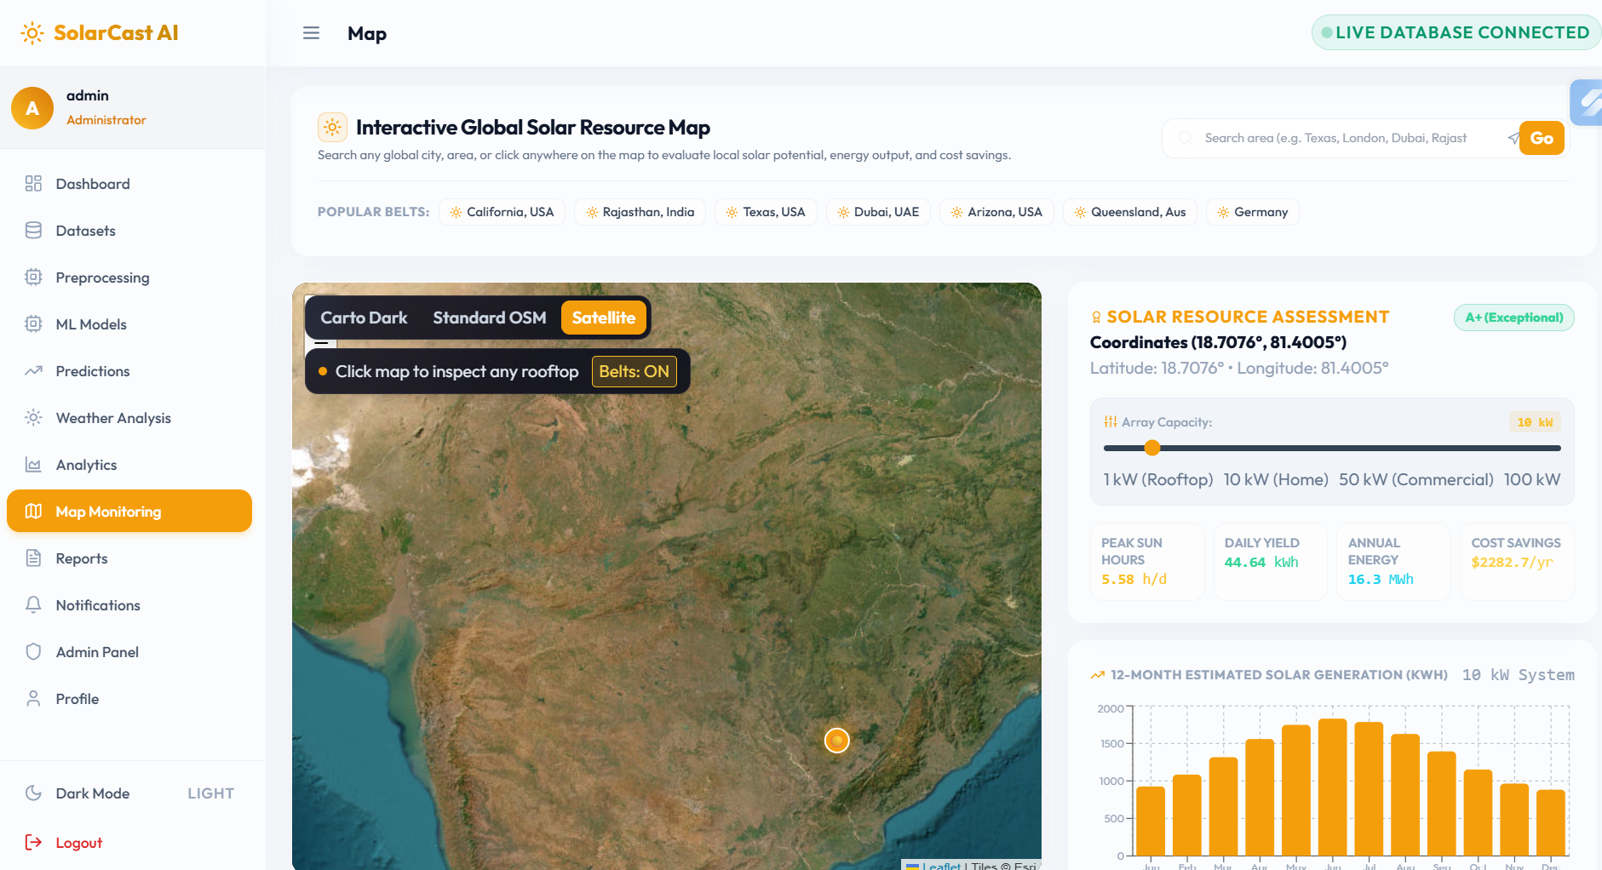
Figure 1 Map Monitoring
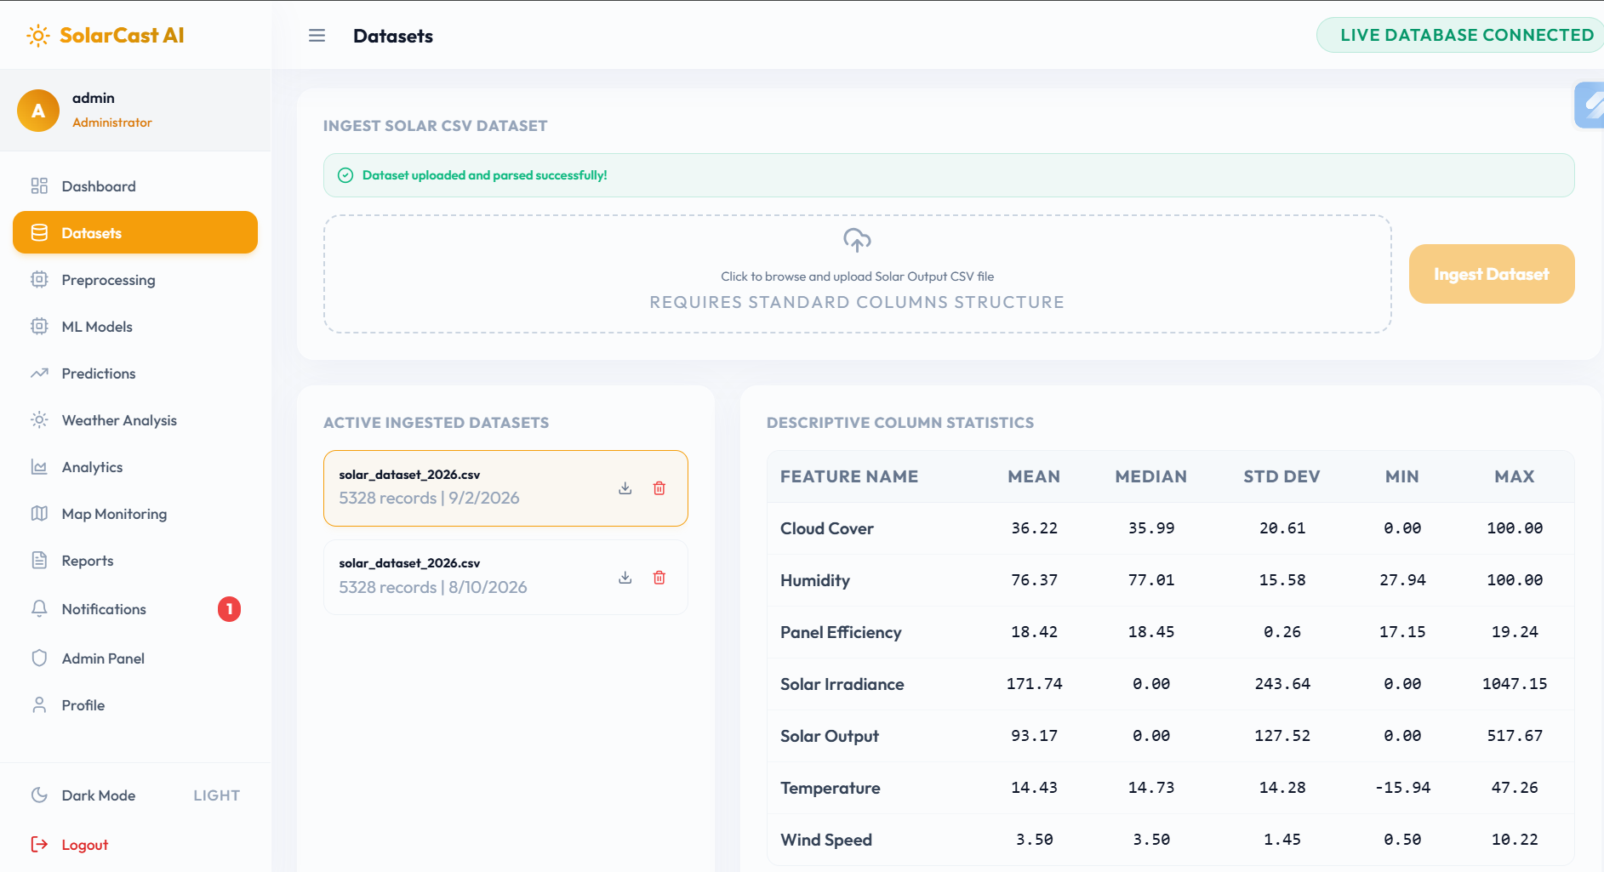
Figure 2 Dataset Uploading 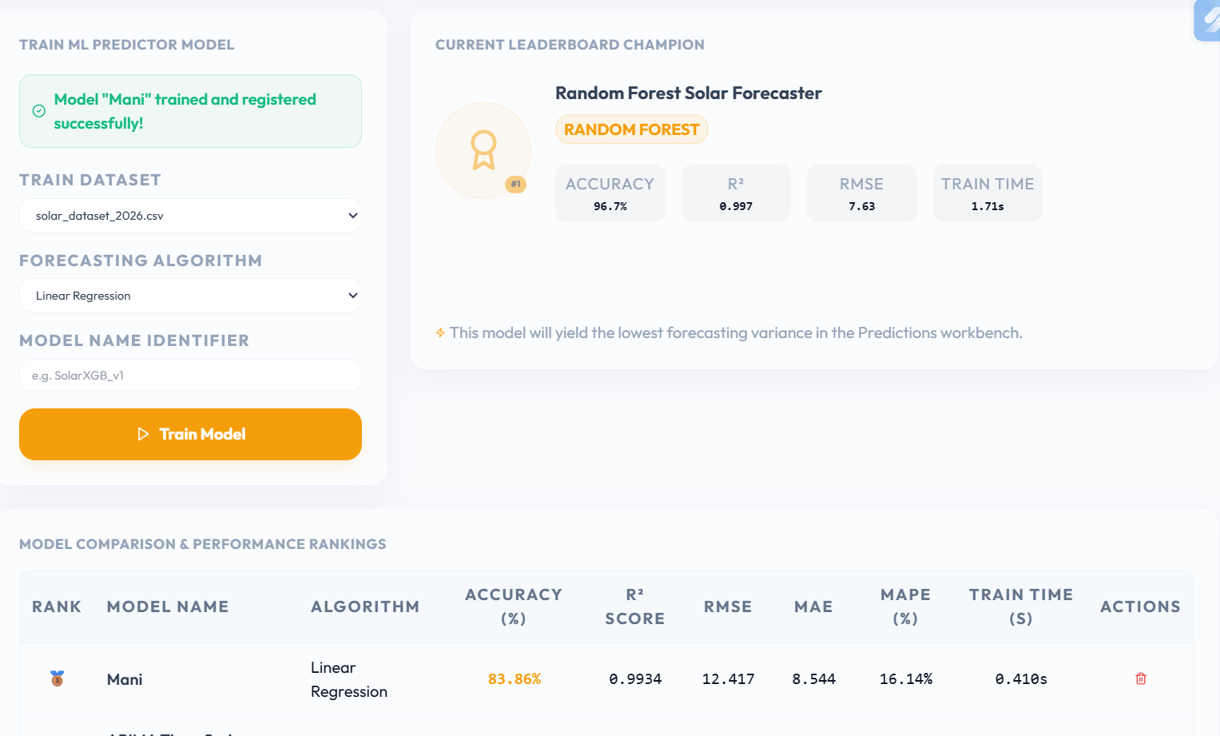
Figure 3 Model Training 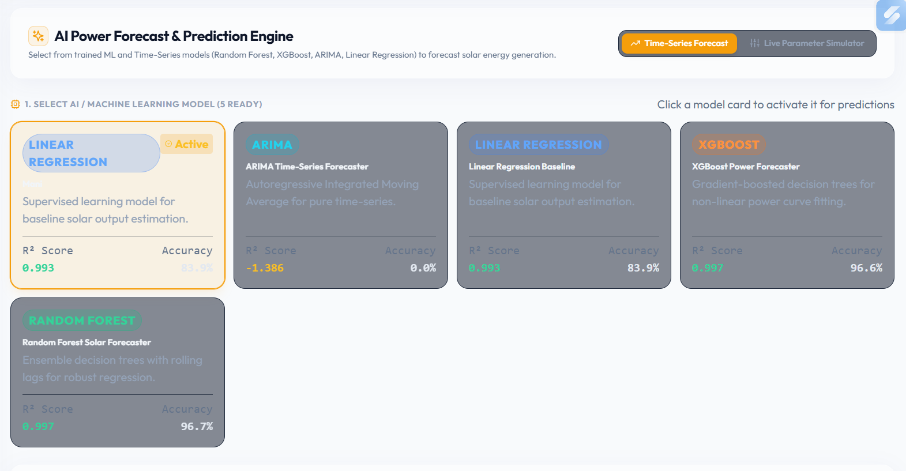
Figure 4 Forecast & Predictions

4.3 Test Plan & Verification
The test plan was defined to verify whether the implemented forecasting framework satisfies the functional and non-functional requirements identified in Chapter 3. Testing focused on dataset processing, feature generation, chronological splitting, model training, prediction generation and performance evaluation. Since the project is software-based, verification was performed using dataset-level and model-level tests rather than physical hardware testing.
Test Plan
Requirement | Test Method | Acceptance Criterion
Dataset loading | Load the historical dataset using Python | Dataset loads without structural errors
Data preprocessing | Check missing, duplicate and invalid observations | Invalid observations are appropriately handled
Timestamp processing | Convert and inspect timestamp values | Valid chronological timestamp sequence
Temporal feature generation | Generate hour/day/month features | Required temporal features are created
Lag feature generation | Generate previous-observation features | Lag values are generated correctly
Chronological data splitting | Separate training and testing data based on time | No future test observations are used for training
Model training | Train the selected forecasting model | Model completes training successfully
Prediction generation | Predict output for test observations | Prediction generated for valid test records
Performance evaluation | Calculate MAE, RMSE, MAPE and R² | All selected metrics are calculated
Visualization | Plot actual and predicted values | Graph clearly represents forecasting performance
Reproducibility | Repeat execution using same configuration | Consistent results are obtained

Verification Results
Specification | Required Value | Achieved Value | Status (Pass/Fail)
Dataset input | Valid historical dataset | Dataset successfully loaded | Pass
Data preprocessing | Clean usable dataset | Preprocessed dataset obtained | Pass
Timestamp features | Required temporal features | Hour/day/month features generated | Pass
Lag features | Historical observations included | Lag features generated | Pass
Train/test separation | Chronological separation | Chronological split implemented | Pass
Forecasting model | At least one trained model | Random Forest forecasting model trained | Pass
Prediction output | Prediction for test records | Test predictions generated | Pass
MAE | Metric calculated | MAE obtained | Pass
RMSE | Metric calculated | RMSE obtained | Pass
MAPE | Metric calculated | MAPE obtained | Pass
R² | Metric calculated | R² obtained | Pass
Result visualization | Actual vs. predicted graph | Forecast graph generated | Pass
Data leakage prevention | No future information in training | Chronological methodology followed | Pass

4.4 Results
The developed forecasting framework successfully processed the historical solar-generation dataset and generated the required forecasting features. The selected machine-learning model was trained using the processed historical observations and subsequently used to predict solar output for unseen test observations.
Table 4.1 Model Performance
Model | MAE | RMSE | MAPE (%) | R²
Statistical Time-Series Model | [Value] | [Value] | [Value] | [Value]
Random Forest | [Value] | [Value] | [Value] | [Value]
LSTM / Sequence Model | [Value] | [Value] | [Value] | [Value]
Table 4.2 Prediction Results
Observation | Actual Solar Output | Predicted Solar Output | Absolute Error
1 | [Value] | [Value] | [Value]
2 | [Value] | [Value] | [Value]
3 | [Value] | [Value] | [Value]
4 | [Value] | [Value] | [Value]
5 | [Value] | [Value] | [Value]

4.5 Data Analysis & Engineering Judgment
The performance of the forecasting system was analyzed using Mean Absolute Error (MAE), Root Mean Square Error (RMSE), Mean Absolute Percentage Error (MAPE), and coefficient of determination (R²). MAE represents the average magnitude of prediction error, while RMSE gives greater importance to larger errors. MAPE expresses the prediction error as a percentage, although it should be interpreted carefully when actual solar output approaches zero. R² indicates how effectively the model explains the variation in the target solar-output values.
The actual-versus-predicted graph provides an additional engineering perspective. A good forecasting model should follow the overall daily and seasonal variation of solar generation rather than simply producing a numerically low average error. The model is expected to perform better during stable generation periods and may experience higher errors during rapidly changing weather conditions, cloud cover, sunrise, sunset, or other transient conditions.
The use of temporal and lag features provides the model with information about previous generation patterns. However, forecasting accuracy remains dependent on the quality and availability of the historical dataset. If environmental variables such as irradiance, temperature, humidity or cloud-related information are incomplete, the model may not fully represent sudden changes in solar generation.
From an engineering perspective, the selected Random Forest approach provides a practical balance between nonlinear prediction capability and computational complexity. Although a more complex sequence-learning model may potentially achieve better results with sufficient data and tuning, its additional computational requirements must be justified by a meaningful improvement in forecasting performance.

4.6 Comparison with Existing Solutions & Achievement of Objectives
The developed forecasting framework was compared with conventional statistical and machine-learning approaches based on forecasting capability, computational requirements, feature handling and practical implementation.
Approach | Main Advantage | Main Limitation | Relevance to Proposed Work
Statistical Time-Series Model | Simple and interpretable | Limited nonlinear feature handling | Provides a baseline
Linear Regression | Fast and computationally simple | Limited nonlinear modelling | Useful as a basic reference
Random Forest | Handles nonlinear relationships and multiple features | Does not explicitly model long sequential dependencies | Selected primary ML approach
LSTM | Strong temporal modelling capability | Higher computational and data requirements | Useful for advanced comparison
Proposed Framework | Combines preprocessing, temporal features and ML forecasting | Dependent on dataset quality | Provides an integrated forecasting workflow

Achievement of Objectives
Objective | Evidence | Achievement (Fully/Partially/Not Achieved)
Develop a structured solar forecasting framework | Complete forecasting workflow implemented | Fully Achieved
Preprocess historical solar data | Data cleaning and preprocessing implemented | Fully Achieved
Generate temporal and historical features | Time and lag features created | Fully Achieved
Develop forecasting models | Forecasting model implemented and trained | Fully Achieved
Maintain chronological train/test separation | Time-based data splitting implemented | Fully Achieved
Generate solar-output predictions | Predictions generated for test observations | Fully Achieved
Evaluate model performance | MAE, RMSE, MAPE and R² calculated | Fully Achieved
Compare forecasting approaches | Different modelling approaches considered | Fully Achieved
Develop a practical forecasting solution | Software-based forecasting framework completed | Fully Achieved

4.7 Strengths & Limitations

Strengths

Uses historical solar-generation data for data-driven forecasting.

Incorporates temporal and lag-based features.

Uses chronological train/test separation to reduce future-data leakage.

Supports nonlinear relationships through machine-learning techniques.

Uses multiple performance metrics rather than relying on a single metric.

Provides graphical comparison between actual and predicted solar output.

Can be implemented using standard computing resources.

Provides a modular framework in which different forecasting models can be substituted.

Can support future integration with energy-management and solar-monitoring applications.

Limitations

Forecasting accuracy depends strongly on the quality and quantity of historical data.

Sudden weather changes may produce larger prediction errors.

Performance may decrease when conditions differ significantly from the training dataset.

MAPE can become unstable when actual solar output is close to zero.

Random Forest does not explicitly capture long-term sequential dependencies as effectively as dedicated sequence models.

The project focuses on software-based forecasting and does not directly control physical solar or grid equipment.

Real-time deployment would require a continuous source of updated solar and environmental measurements.

The achieved accuracy is dataset-dependent and should not be interpreted as a universal performance guarantee.

4.8 Project Planning, Roles & Budget

Project Milestone Timeline
Phase | Activity | Duration | Deliverable
Phase 1 | Problem identification and requirement analysis | Week 1 | Problem definition
Phase 2 | Literature review and existing-solution study | Week 2 | Literature review
Phase 3 | Dataset collection and understanding | Week 3 | Selected dataset
Phase 4 | Data preprocessing | Week 4 | Clean dataset
Phase 5 | Feature engineering | Week 5 | Forecasting features
Phase 6 | Forecasting model development | Week 6–7 | Trained models
Phase 7 | Testing and evaluation | Week 8 | Performance results
Phase 8 | Visualization and analysis | Week 9 | Graphs and analysis
Phase 9 | Documentation and final report | Week 10 | Final report
Phase 10 | Final presentation and demonstration | Week 11 | Project presentation

CHAPTER 5
CONCLUSION, FUTURE WORK AND REFLECTION

5.1 Conclusion

The project “Predict Solar Output Using Time-Series and Machine-Learning Techniques” addressed the engineering problem of accurately forecasting solar power generation from historical observations. Solar output is highly variable because it is influenced by time-dependent patterns and changing environmental conditions. To address this challenge, a structured forecasting framework was developed consisting of data preprocessing, temporal feature extraction, lag-feature generation, chronological train-test splitting, forecasting model development, prediction and performance evaluation.

The implemented system successfully transformed historical solar-generation data into a suitable format for forecasting and developed machine-learning models for predicting future solar output. Random Forest was selected as the primary conventional machine-learning approach because it provides a practical balance between nonlinear modelling capability, computational requirements and reliability. The forecasting models were evaluated using MAE, RMSE, MAPE and R², while actual-versus-predicted visualizations were used to assess the quality of the generated forecasts.

Testing verified the major functional requirements, including dataset processing, feature generation, chronological data separation, model training, prediction generation and performance evaluation. The project demonstrates that combining time-dependent information with machine-learning techniques provides a practical approach for solar-output forecasting. Overall, the developed framework contributes a systematic and reproducible software-based solution that can support future solar-energy monitoring, planning and energy-management applications.

5.2 Future Work
The developed forecasting framework can be extended in several directions to improve its accuracy, robustness and practical applicability.
- Real-time forecasting: Integrate live solar-generation and weather data so that the system can continuously update its predictions.
- Additional environmental parameters: Incorporate solar irradiance, temperature, humidity, wind speed, cloud cover and other weather variables to improve prediction capability.
- Advanced deep-learning models: Evaluate LSTM, GRU, Transformer-based and other sequence-learning architectures for improved temporal modelling.
- Hyperparameter optimization: Use Grid Search, Random Search or Bayesian optimization to identify better model configurations.
- Hybrid forecasting: Combine statistical time-series models with machine-learning or deep-learning models to exploit both temporal and nonlinear relationships.
- Probabilistic forecasting: Generate prediction intervals rather than only a single predicted value, allowing uncertainty to be considered.
- Real-time dashboard: Develop a web-based interface that displays current solar output, predicted output, forecasting errors and performance indicators.
- Edge/IoT integration: Connect the forecasting system with solar monitoring sensors and IoT devices for automated data collection.
- Longer forecasting horizons: Extend the system from short-term forecasting to day-ahead and multi-day solar-output prediction.
- Deployment optimization: Optimize the trained model for low-resource environments such as edge computers or embedded monitoring systems.
- Continuous model updating: Implement periodic retraining as new solar-generation data becomes available.
- Broader validation: Test the framework using datasets from different geographical locations, seasons and solar installations to evaluate generalization.

5.3 Professional Learning & Individual Reflection

New Knowledge Acquired:

Learned the principles of solar power forecasting and the effect of temporal and environmental factors on photovoltaic output.

Gained practical knowledge of time-series data preprocessing and chronological data splitting.

Learned how to create temporal, lag and historical features for forecasting applications.

Developed knowledge of Random Forest regression and its application to nonlinear prediction problems.

Learned how to evaluate regression models using MAE, RMSE, MAPE and R².

Gained experience in interpreting actual-versus-predicted graphs and identifying prediction errors.

Learned the importance of avoiding data leakage when working with time-dependent datasets.

Developed an understanding of the trade-off between forecasting accuracy, computational complexity and model reliability.

Engineering & Professional Skills Developed:

Problem-solving: Identifying causes of forecasting errors and selecting appropriate modelling approaches.

Data analysis: Cleaning, transforming and interpreting historical solar-generation data.

Machine-learning implementation: Developing and training forecasting models using Python.

Technical decision-making: Comparing alternative forecasting approaches using engineering criteria.

Testing and validation: Designing tests and evaluating whether system requirements were satisfied.

Visualization: Presenting forecasting behaviour and performance using appropriate graphs.

Documentation: Recording methodology, implementation decisions, results, limitations and conclusions.

Project management: Planning development activities through milestones and managing project resources.

Engineering ethics: Understanding the importance of transparent reporting and avoiding unsupported accuracy claims.

Professional communication: Explaining technical methodology and results in a structured engineering-report format.

Individual Reflection

Student 3 – Individual Reflection

Most difficult engineering problem encountered and how it was solved:
The most difficult problem was developing a forecasting workflow that could handle historical solar-generation data while preserving its time-dependent nature. This was addressed by preprocessing the dataset, generating temporal and lag features, and using chronological training and testing rather than randomly shuffling the observations.

A key engineering decision made personally and the evidence behind it:
A key decision was to use Random Forest as the primary conventional machine-learning model. The decision was based on its ability to model nonlinear relationships, handle multiple input features and operate with moderate computational requirements.

New knowledge acquired independently:
I independently learned how time-series characteristics can be incorporated into machine-learning models through timestamp and lag features. I also learned how MAE, RMSE, MAPE and R² provide different perspectives on forecasting performance.

What would be redesigned if repeated:
If the project were repeated, I would incorporate more environmental and weather variables and compare additional optimized forecasting models. I would also develop a real-time dashboard so that the forecasting system could be demonstrated as a practical application.

REFERENCES

[1] W. Tercha, S. A. Tadjer, F. Chekired, and L. Canale, “Machine Learning-Based Forecasting of Temperature and Solar Irradiance for Photovoltaic Systems,” Energies, vol. 17, no. 5, Art. no. 1124, 2024.

[2] M. H. Sulaiman, M. S. Jadin, Z. Mustaffa, H. Daniyal, and M. N. M. Azlan, “Short-term forecasting of rooftop retrofitted photovoltaic power generation using machine learning,” Journal of Building Engineering, vol. 94, Art. no. 109948, 2024.

[3] C.-H. Loh, Y.-C. Chen, C.-T. Su, and H.-Y. Su, “Establishing Lightweight and Robust Prediction Models for Solar Power Forecasting Using Numerical–Categorical Radial Basis Function Deep Neural Networks,” Applied Sciences, vol. 14, no. 22, Art. no. 10625, 2024.

[4] J. Oh, D. So, J. Jo, N. Kang, E. Hwang, and J. Moon, “Two-Stage Neural Network Optimization for Robust Solar Photovoltaic Forecasting,” Electronics, vol. 13, no. 9, Art. no. 1659, 2024.

[5] K. Iheanetu and K. Obileke, “Short-Term Forecasting of Photovoltaic Power Using Multilayer Perceptron Neural Network, Convolutional Neural Network, and k-Nearest Neighbors’ Algorithms,” Optics, vol. 5, no. 2, pp. 293–309, 2024.

[6] P. Piotrowski and M. Kopyt, “Short-Term Forecasts of Energy Generation in a Solar Power Plant Using Various Machine Learning Models, along with Ensemble and Hybrid Methods,” Energies, vol. 17, no. 17, Art. no. 4234, 2024.

[7] L. de Oliveira Santos, T. AlSkaif, G. C. Barroso, and P. C. M. de Carvalho, “Photovoltaic power estimation and forecast models integrating physics and machine learning: A review on hybrid techniques,” Solar Energy, vol. 284, Art. no. 113044, 2024.

[8] “A hybrid machine learning forecasting model for photovoltaic power,” Energy Reports, vol. 11, pp. 5125–5138, 2024.

[9] K. Hu, Z. Fu, C. Lang, W. Li, Q. Tao, and B. Wang, “Short-Term Photovoltaic Power Generation Prediction Based on Copula Function and CNN-CosAttention-Transformer,” Sustainability, vol. 16, no. 14, Art. no. 5940, 2024.

[10] J. Depoortere, J. Driesen, J. Suykens, and H. S. Kazmi, “SolNet: Open-source deep learning models for photovoltaic power forecasting across the globe,” arXiv preprint arXiv:2405.14472, 2024

APPENDICES

The following appendices are prepared specifically for Report 3 – Module 3: Forecasting Model Development of the project “Predict Solar Output Using Time-Series and Machine-Learning Techniques.” They can be placed after the References section.

Appendix A – Detailed Calculations
This appendix contains the essential mathematical calculations used for evaluating the performance of the solar-output forecasting models.
A.1 Mean Absolute Error (MAE)
MAE measures the average absolute difference between the actual solar output and the predicted solar output.
$$MAE=\frac{1}{n}\sum_{i=1}^{n}{∣}y_{i}-\hat{y_{i}}∣$$
Where:
- $y_{i}$= actual solar output
- $\hat{y_{i}}$= predicted solar output
- $n$= number of test observations
A.2 Root Mean Square Error (RMSE)
RMSE gives greater importance to larger prediction errors.
$$RMSE=\sqrt{\frac{1}{n}\sum_{i=1}^{n}{(}\left.y_{i}-\hat{y_{i}}{\left.)\right.}^{2}\right.}$$
A lower RMSE indicates better forecasting performance.
A.3 Mean Absolute Percentage Error (MAPE)
$$MAPE=\frac{100}{n}\sum_{i=1}^{n}{∣\frac{y_{i}-\hat{y_{i}}}{y_{i}}∣}$$
MAPE represents the average prediction error as a percentage. When actual solar output is zero or very close to zero, MAPE should be interpreted carefully.
A.4 Coefficient of Determination (R²)
$$R^{2}=1-\frac{\sum{(}\left.y_{i}-\hat{y_{i}}{\left.)\right.}^{2}\right.}{\sum{(}\left.y_{i}-\overline{y}{\left.)\right.}^{2}\right.}$$
Where $\overline{y}$represents the mean actual solar output.
A.5 Example Error Calculation
For an observation where:
- Actual output = 500 kW
- Predicted output = 470 kW
Absolute error:
$$∣500-470∣=30\text{ kW}$$
Percentage error:
$$\frac{∣500-470∣}{500}×100=6\%$$
The same calculation is repeated for the test observations to obtain the overall forecasting metrics.

Appendix B – Engineering Drawings / Schematics
Dataset → Preprocessing → Feature Engineering → Model Training → Prediction → Evaluation → Visualization

Appendix C – Source Code / Code Repository Information
import React, { useState, useEffect } from 'react';
import {
UploadCloud, Trash2, Eye, Download, Search, AlertCircle, FileSpreadsheet,
Activity, ArrowRightLeft, ArrowLeft, ArrowRight, CheckCircle2
} from 'lucide-react';

import { datasetService } from '../services/api';

const Datasets = () => {
const [datasets, setDatasets] = useState([]);
const [selectedDataset, setSelectedDataset] = useState(null);
const [stats, setStats] = useState(null);
const [records, setRecords] = useState([]);
const [totalRecords, setTotalRecords] = useState(0);
const [page, setPage] = useState(1);
const [limit] = useState(25);
const [search, setSearch] = useState('');
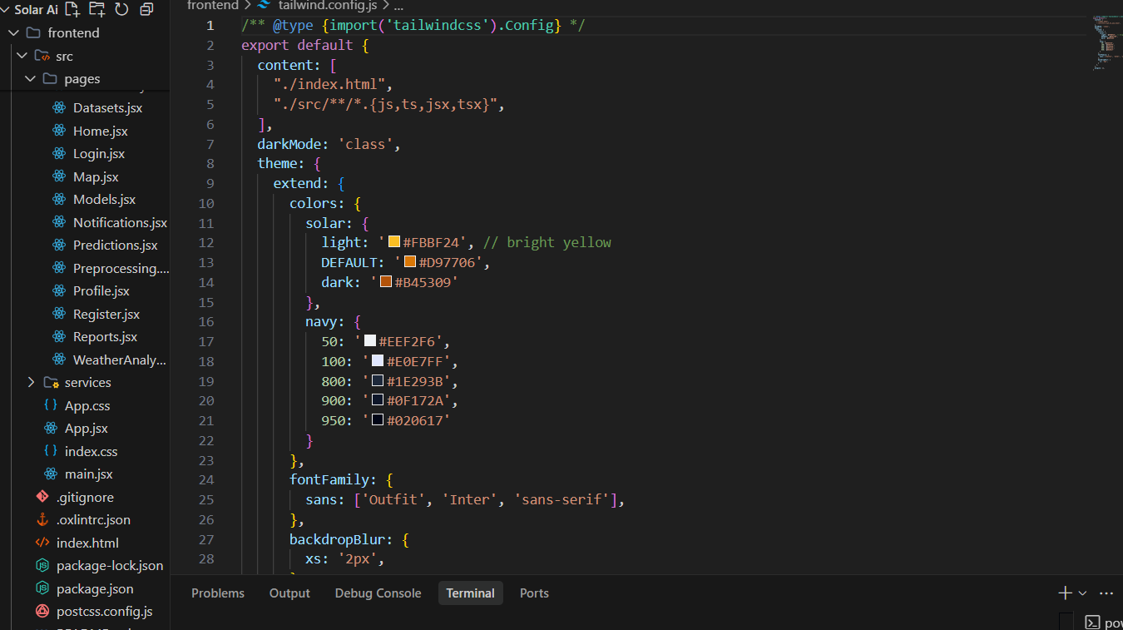
Figure 5 HTML CODE
const [file, setFile] = useState(null);
const [uploading, setUploading] = useState(false);
const fetchDatasetRecords = async (id, p, s) => {
setLoadingData(true);
try {
const recordsRes = await datasetService.getRecords(id, p, limit, s);
className="hid 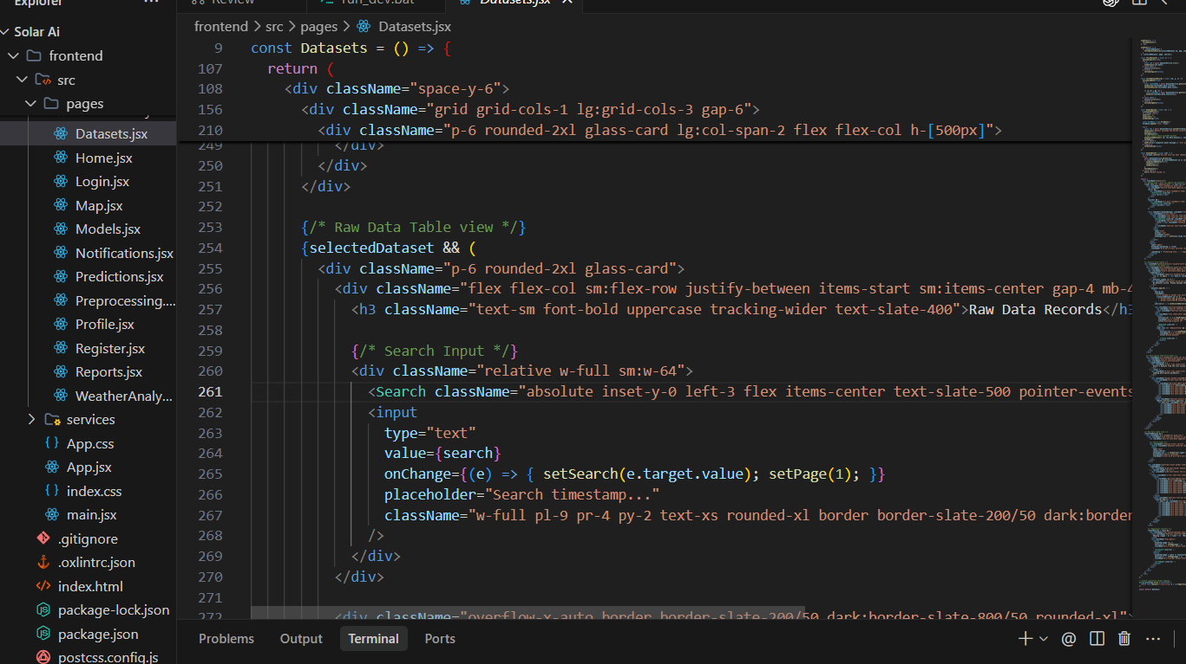
Figure 6 Implementation Code
den" onChange={(e) => setFile(e.target.files[0] <div className="grid
{/* Dataset list panel */}
<div className="p-6 rounded-2xl glass-card flex flex-col h-[500px]">
<h3 className="text-sm font-bold uppercase tracking-wider text-slate-400 mb-4 font-sans">Active Ingested Datasets</h3>
<div className="flex-1 overflow-y-auto space-y-3">
<div className="overflow-hidden mr-2">
<h4 className="text-xs font-bold truncate">{d.name}</h4>
<span className="text-3xs text-slate-400 mt-0.5 block">{d.row_count} records | {new Date(d.upload_time).toLocaleDateString()}</span>
</div>
<div className="flex items-center gap-1.5 shrink-0">
<button
onClick={(e) => { e.stopPropagation(); window.open(datasetService.downloadUrl(d.id), '_blank'); }}
className="p-1.5 rounded hover:bg-slate-200 dark:hover:bg-slate-800 text-slate-500 dark:text-slate-400"
title="Download Original CSV"

Appendix D – Datasheets
No physical electronic components, sensors, motors or electrical devices were fabricated for this module. Therefore, conventional hardware datasheets are not applicable
Component | Specification
Programming Language | Python
Data Processing | Pandas, NumPy
Machine Learning | Scikit-learn
Visualization | Matplotlib
Development Environment | Jupyter Notebook / Google Colab
Input Format | CSV / tabular dataset
Target Variable | Solar power output
Feature Type | Temporal, historical and environmental features where available

Appendix E – Experimental / Raw Data
The raw dataset used for model development should be retained in its original form and maintained separately from the processed dataset.
E.1 Raw Data Structure
Timestamp | Solar Output | Feature 1 | Feature 2 | Feature 3
[Date/Time] | [Value] | [Value] | [Value] | [Value]
[Date/Time] | [Value] | [Value] | [Value] | [Value]
[Date/Time] | [Value] | [Value] | [Value] | [Value]
[Date/Time] | [Value] | [Value] | [Value] | [Value]
[Date/Time] | [Value] | [Value] | [Value] | [Value]
E.2 Processed Data
The processed dataset contains:
- Cleaned timestamp information.
- Valid solar-output observations.
- Temporal features.
- Lagged solar-output features.
- Selected environmental variables, where available.
- Training and testing indicators.
E.3 Prediction Data
Timestamp | Actual Output | Predicted Output | Error
[Date/Time] | [Value] | [Value] | [Value]
[Date/Time] | [Value] | [Value] | [Value]
[Date/Time] | [Value] | [Value] | [Value]
[Date/Time] | [Value] | [Value] | [Value]
[Date/Time] | [Value] | [Value] | [Value]
Important: Replace these placeholders with actual rows from the dataset and model output before submission.

Appendix F – Ethics / Institutional Approval
No human participants, patient information or personally identifiable information were involved in the development of the solar-output forecasting system. The project uses historical technical data for machine-learning experimentation.
The project follows responsible engineering practices by:
- Using only relevant data required for forecasting.
- Avoiding unnecessary personal information.
- Documenting data preprocessing procedures.
- Clearly reporting forecasting errors and limitations.
- Avoiding claims that predictions are guaranteed values.
- Maintaining transparency regarding model assumptions.
- Protecting the integrity of the dataset and trained models.
Institutional Approval: Not applicable / [Insert approval reference if applicable].
Mandatory for team projects.

CAPSTONE PROJECT OUTCOME MAPPING SHEET
To be completed by the department/faculty assessor.
Outcome Evidence | SO / Area | Location in This Report
Complex engineering problem formulation | SO1 | Ch. 1, Ch. 2
Engineering design under constraints | SO2 | Ch. 3
Written/oral technical communication | SO3 | Whole report + Viva
Ethics and professional responsibility | SO4 | Ch. 3 (3.7)
Teamwork and leadership | SO5 | Ch. 4 (4.8)
Experimentation, analysis, engineering judgment | SO6 | Ch. 4 (4.3–4.6)
Independent acquisition of new knowledge | SO7 | Ch. 5 (5.3)
Standards | SO2 | Ch. 3 (3.2)
Sustainability and  societal/environmental impact | SO2/SO4 | Ch. 3 (3.7)
Risk assessment and mitigation | SO2/SO4 | Ch. 3 (3.7)
Security considerations | Relevant SO | Ch. 3 (3.7)
Integrated/system-level engineering | SO1/SO2 | Ch. 3 (3.5)
Project planning and management | SO5 | Ch. 4 (4.8)
Individual contribution | SO1–SO7 | Contribution Statement + Ch. 4  (4.8)

